**19**augsub**001** Marketo
has
**2**
workspaces. Stats below are a sum of assets found across all workspaces.

**Stats**

* They have **null** campaigns
* They have **null** active campaigns
* They have **null** triggered campaigns
* They have **null** Active triggered campaigns
* They have **null** re-occurring batch campaigns
* They have **null** batch campaigns
* **null** landing pages
* **null** forms
* **null** emails
* **null**
  Snippets
* **null** uploaded files
* **0**
  Leads
* **369** programs

**Programs**

**19**augsub**001** Marketo, has created a lot of campaigns and content in Marketo. There are two types of smart campaigns: Batch and Trigger. A batch campaign launches at a specific time and affects a specific set of leads all at once. A triggered smart campaign affects one lead at a time, based on a triggered event. To learn more about Smart campaigns in Marketo. visit :https://docs.marketo.com/display/public/DOCS/Smart+Campaigns

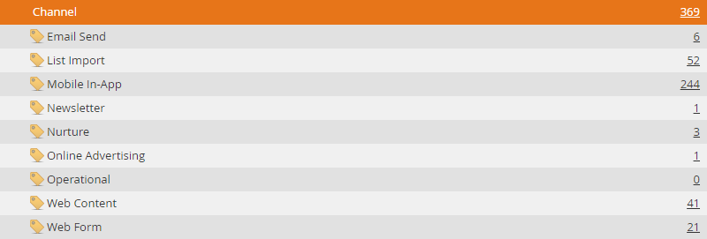

**Models**

**19augsub001 Marketo
has not built models in Marketo. Revenue cycle models take marketing to the next level. They model all the stages of your entire revenue funnel—from when you first interact with a lead all the way until the lead is a won customer.**

**Lead Scoring**

* **19**augsub**001** Marketo
  has a total of
  **32**
  lead scoring campaigns.
* **19**augsub**001** Marketo,
  is executing multiple score changes with single campaigns.
* **19**augsub**001** Marketo
  is using MyTokens in their lead scoring campaigns which allows for a Marketer to quickly, and easily, control from a high level their lead change scores
* **19**augsub**001** Marketo
  has built
  **32**
  campaigns reducing lead scores when leads exhibit undesirable behavior

Marketo’s lead scoring capabilities are far more robust than any other vendor offerings.
Lead scoring allows you to identify which prospects are most interested and engaged with your brand. Marketo also allows the usage of My Tokens in lead scoring campaigns. This allows the marketer to have the ability to control at a high level all of the lead scoring attributes assigned to their campaigns. Additionally, Marketo allows the marketer to add detailed constraints to their lead scoring campaigns, which add a**not**her layer of complexity. For example – leads active during a specific date/time AND who visit the web page numerous times within a certain time window.

**Data Management**

**19**augsub**001** Marketo
has less than **5** data management actions set up. To determine this metric our team looks at the ‘Change Data Value’ flow step in the client’s campaigns. Each ‘Change Data Value’ flow step counts as a data management action.
Good examples of data management "
would be any steps taken to clean up lead data, for example, adding leads to a blacklist triggered by"
a certain action. Here is a walkthrough of how to do that: https://experienceleague.adobe.com/docs/marketo/using/product-docs/core-marketo-concepts/smart-lists-and-static-lists/managing-people-in-smart-lists/add-person-to-blocklist.html?lang=en
Here is a high overview on how to create Change Data Value flow actions: https://docs.marketo.com/display/public/DOCS/Change+Data+Value

**Events**

**19**augsub**001** Marketo has built numerous Event campaigns in Marketo.
One of the greatest features of Marketo is the ability to clone an entire program—which copies all underlying assets and campaigns that are part of that program. Events allow you to automate online and offline events! Capture the status of your leads as they progress through different stages and get accurate measures of the ROI for your marketing initiatives.

**Nurture19**augsub**001** Marketo
has
**3**
Nurture campaigns using the Marketo Nurture Stream engine. There are two types of Content you can add to engagement program streams — emails and programs. Emails will be sentto leads at cast time. Marketo's smart streams also offer:

* **Intelligently and automatically deliver content to a target audience.**
* **Easily build dialogue with prospects and customers while preventing customers who have already received content from receiving the same content again.**
* **Add new content and entire programs to nurture streams.**
* **Edit the availability of content.**
* **Understand content performance based on engagement with each piece of content.**

**Segmentation**

**19**augsub**001** Marketo
does **not** have any segments defined. Segmentation categorizes your audience into different subgroups based on a Smart List rule. These groups are called segments. Segments allow the marketer to target leads based on the segment that they fall into.

**Program Library**

It appears that
**19**augsub**001** Marketo
has imported templates from the Marketo Program Library.
Marketo is committed to our customers' success and has seeded a ton of pre-built programs for almost any use case into the Marketo Program Library that our customers are free to import when they are needed as their marketing strategies evolve and call for different types of programs and campaigns.

**Integrations**

**19**augsub**001** Marketo
has **not** installed any integrations.Marketo LaunchPoint is the most complete ecosystem of Marketing solution integrations in the industry. LaunchPoint offers hundreds of applications that complement and integrate into Marketo’s customer engagement platform. LaunchPoint gives Marketers access to the best applications, solutions and services that drive engagement and build revenue.